
AI-Powered Job Application Reviewer


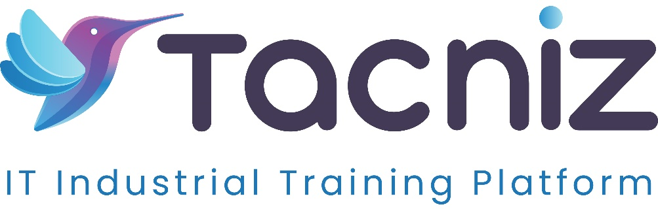

Problem Statement
Job seekers often struggle to create resumes and cover letters that align with the specific requirements of job descriptions. Many applications fail to highlight the right skills, experience, or keywords, reducing the chances of being noticed by recruiters or Applicant Tracking Systems (ATS). An AI-powered job application reviewer can analyze resumes and cover letters, comparing them to job descriptions, and provide actionable suggestions to optimize job applications.

Type
  - AI-based Resume and Cover Letter Optimization Tool.

Industry Area
  - Recruitment, Career Counseling, Human Resources, Job Search Platforms.

Software Expertise Required
  - Natural Language Processing (NLP): Python (spaCy, NLTK) for analyzing job descriptions and resumes to identify relevant skills, experience, and keywords.
  - Machine Learning & AI: TensorFlow, PyTorch for training models that can evaluate job applications and suggest improvements.
  - Data Analytics: Python (pandas, NumPy) for comparing job descriptions with resumes and identifying gaps in skills or experience.
  - Frontend Development: React.js, Vue.js, or Angular for building an intuitive user interface for uploading resumes, cover letters, and job descriptions.
  - Backend Development: Python (Flask/Django) or Node.js to manage job descriptions, user data, and AI-generated feedback.
  - Database: PostgreSQL, MySQL, or MongoDB to store user profiles, resumes, job descriptions, and feedback reports.

Use Cases
  - Job Seekers: Upload their resumes and cover letters alongside job descriptions, and the system will provide a detailed analysis, highlighting missing skills, experience gaps, and suggestions for improvements.
  - Skills Matching: The tool will recommend industry-specific skills and keywords that job seekers should include to better match ATS requirements.
  - Personalized Feedback: Users receive tailored feedback on improving the structure, language, and content of their resumes and cover letters, ensuring better alignment with the job description.
  - Optimization for ATS: The tool checks resumes for ATS-friendly formatting and keyword optimization to improve the chances of passing through automated screening systems.

Outcomes
  - Job seekers improve the quality and relevance of their resumes and cover letters, increasing their chances of landing interviews.
  - Personalized and actionable feedback helps users focus on the most critical aspects of their applications, ensuring better alignment with job descriptions.
  - Automated optimization reduces the need for costly resume-writing services, making it accessible to all job seekers.

Benefits
  - For Job Seekers:
    - Improved chances of being shortlisted by ensuring resumes and cover letters align with job descriptions.
    - ATS-friendly formatting and keyword suggestions help applications pass through automated screening systems.
    - Personalized feedback enhances application quality, providing insights into missing skills and areas for improvement.
  - For Career Counselors:
    - Offers an efficient way to assist clients in optimizing their resumes and cover letters for specific job openings.
    - Provides data-driven insights into what recruiters are looking for, helping job seekers craft stronger applications.
  - For Recruitment Platforms:
    - Increases user engagement by offering a value-added service that helps job seekers improve their applications.

Duration
  - Estimated 5-6 months.

